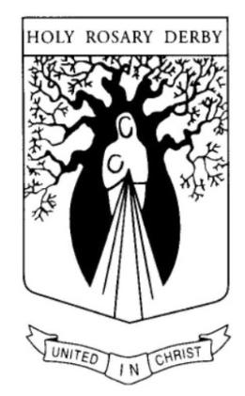

Holy Rosary School Mantra Prayer

Leader We are gathered here before our prayer table.
At our table we are reminded that this place is a sacred place.
This place is sacred because we are gathered here in the name of Jesus our Lord.
This place is sacred because through Jesus’ love, each one of us is special.
Here we can learn to become smarter, stronger, kinder, braver, more understanding, more caring and courageous than we already are.

Boy Here we are safe to be ourselves.
Girl Here we are free from teasing.
Boy Here we are free from fear.
Girl Here we are free from bullying.
Boy Here we are free from payback and violence.
Girl Here we will show the 4Rs – Respect, Responsibility, Resilience and Reverence.
All HERE I AM FREE TO BE ME!

Leader As (Student’s name) lights our candle we remember that we are in a Sacred place and this is our sacred time.
We gather here in the name of the Father, and the Son and the Holy Spirit.
(All bless themselves)
______________ will now read to us from the Bible, the sacred Word of God.

Leader This week (Student or rostered class) is placing (photo or special object) on our prayer table and he / she will invite us to pray.

Student (Shares what they have placed on the table and why it’s important)

Leader (Leader leads class or school in a prayer for the theme of the item(s), reference to the scripture and focus for Church season / RE content of school at current time / Sacrament presently happening or preparations for it.)

